Week 4: Advanced Threat Detection & Web Security
Internship Submission – Phase 4
Author: Geletaw Abebe
Date: Mar 2026

Objective
Implement advanced security controls to detect threats and secure API endpoints using real-world security practices. This week’s tasks focus on building preventive, detective, and protective layers aligned with SOC operations and security engineering principles.

Step 1: Intrusion Detection & Monitoring
Goal: Detect suspicious activities such as brute-force login attempts.
Implementation:
Option A – Fail2Ban (Recommended)
- Install Fail2Ban on the server.
- Monitor authentication logs (e.g., auth.log) or custom application logs.
- Automatically ban IP addresses after multiple failed attempts.
Configuration Logic:
- Maximum retry attempts: 3–5
- Ban duration: 10–30 minutes
In My Project:
- Logged failed login attempts via logger.warn("Failed login attempt")
- Fail2Ban reads these logs and blocks the attacker IP
Screenshot:
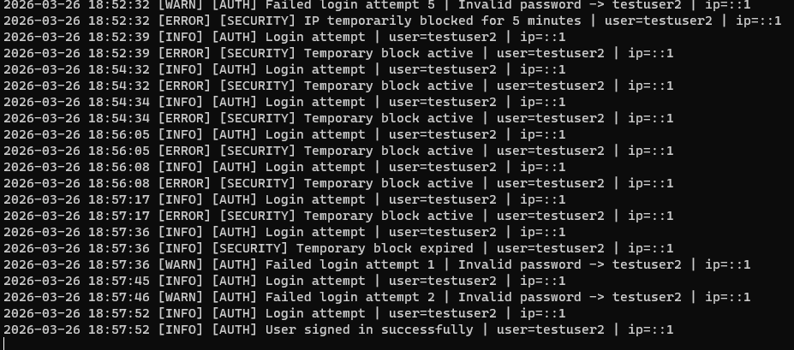

Step 2: API Security Hardening

2.1 Rate Limiting
Goal: Prevent brute-force and DoS attacks
Implementation:
app.use(rateLimit({
windowMs: 60 * 1000, // 1 minute
max: 5 // 5 requests per IP per minute
}));
Result:
- Excessive requests blocked
- HTTP 429 “Too Many Requests” returned
Screenshot:
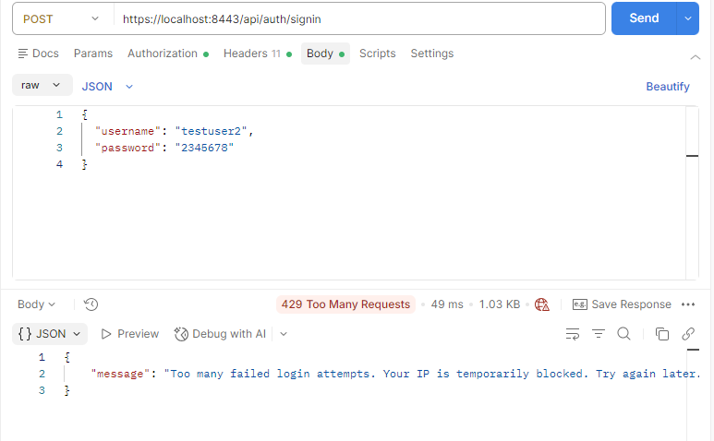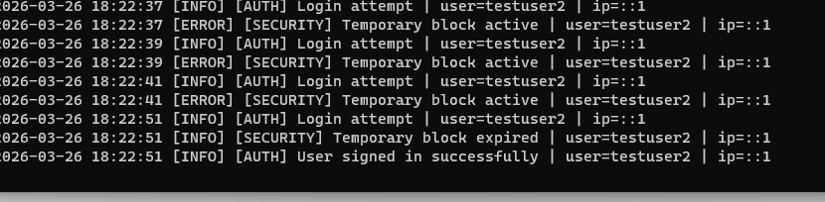

2.2 CORS Configuration
Goal: Allow only trusted frontend domains
Implementation:
app.use(cors({ origin: "http://localhost:8081" }));
Result: Blocks unknown origins
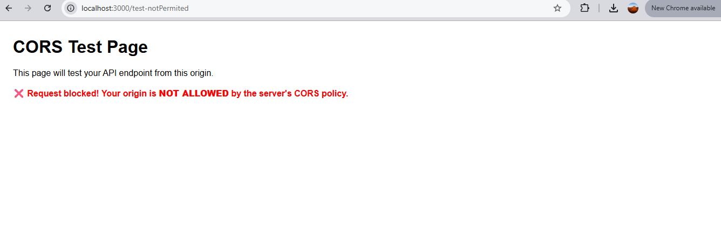
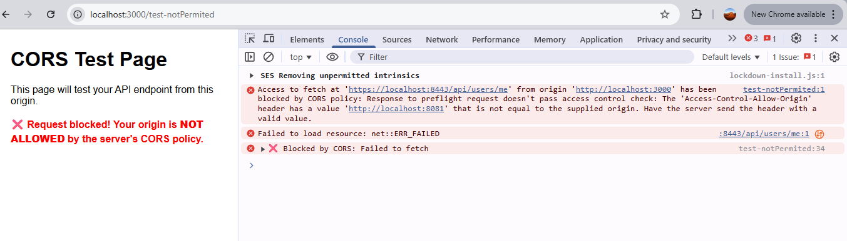
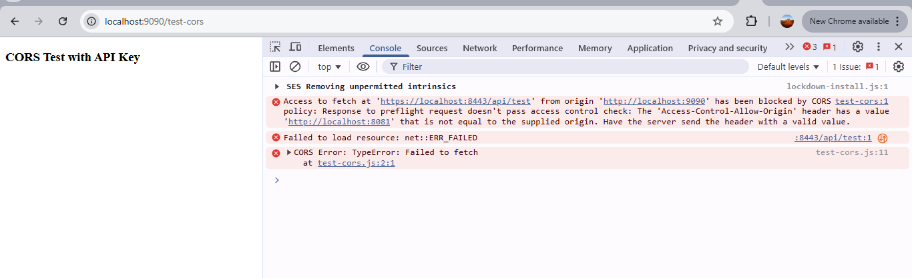

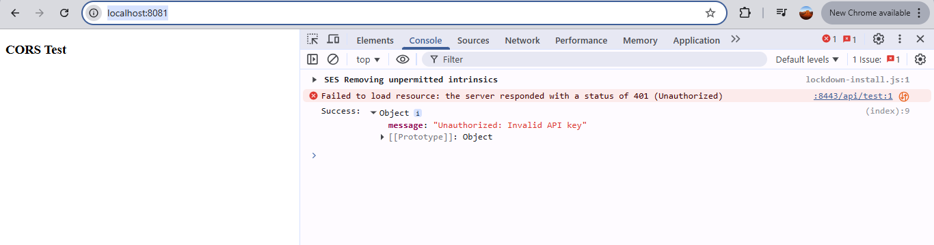
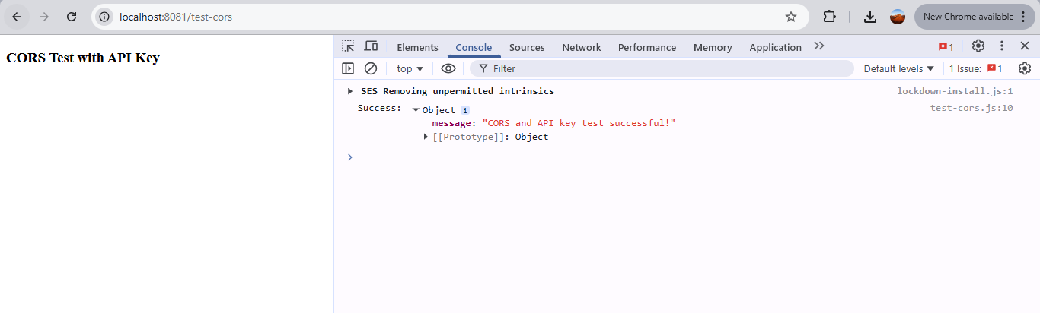

2.3 API Key Authentication
Goal: Add an extra security layer for API access
Implementation:
const key = req.headers["x-api-key"];
if (key !== process.env.API_KEY) {
return res.status(401).json({ message: "Unauthorized: Invalid API key" });
}
Result: Only valid clients can access API
Screenshot:
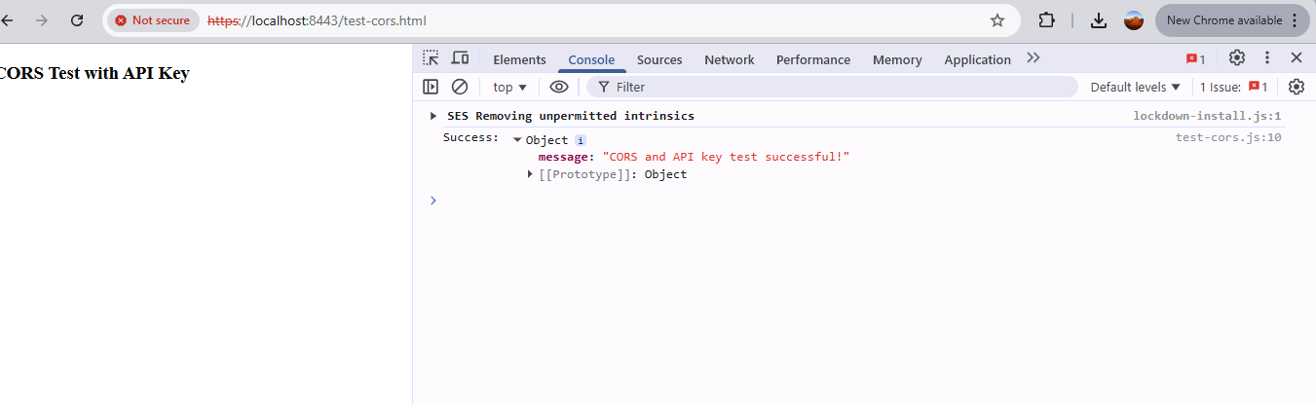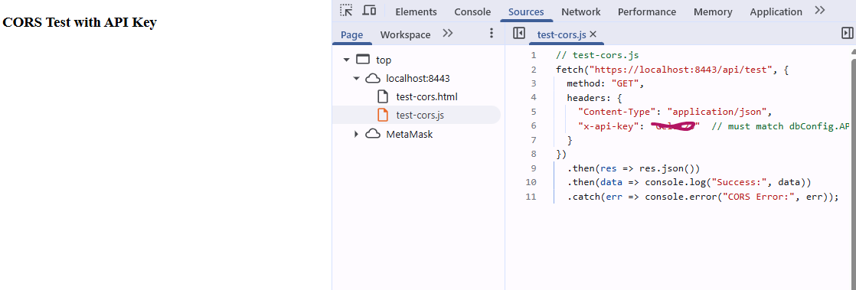

2.4 JWT Authentication
Goal: Secure user authentication with token-based access
Flow:
- User logs in
- Server returns JWT token
- Token used for accessing protected routes
- 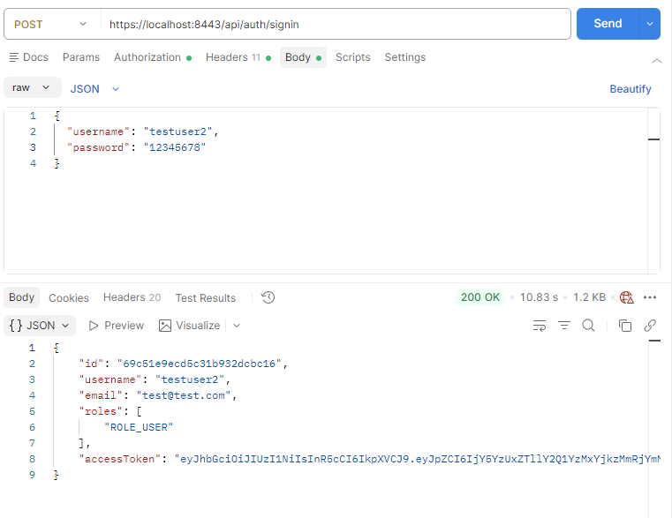
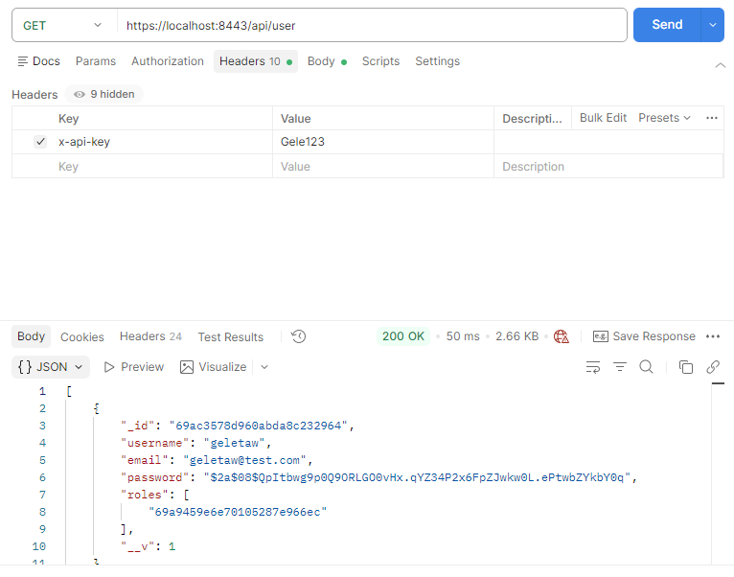
Screenshot:
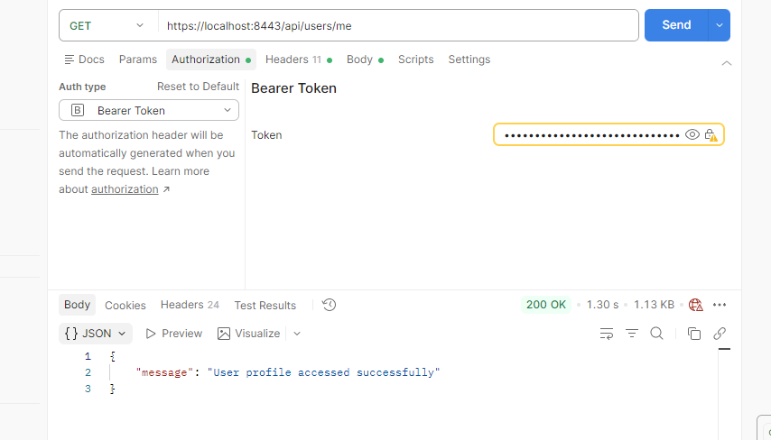

Step 3: Security Headers & CSP

3.1 Helmet
Goal: Secure HTTP headers
Implementation:
app.use(helmet());

3.2 Content Security Policy (CSP)
Goal: Prevent XSS attacks
Implementation:
app.use(
helmet.contentSecurityPolicy({
directives: {
"script-src": ["'self'"]
}
})
);
Screenshot:
[Insert CSP Header Screenshot]

3.3 HTTPS + HSTS
Goal: Encrypt communication and enforce HTTPS
Implementation:
- Use HTTPS server with certificates
- Add HSTS header: app.use(helmet.hsts());
Result: Browser forces HTTPS connections
Screenshot:
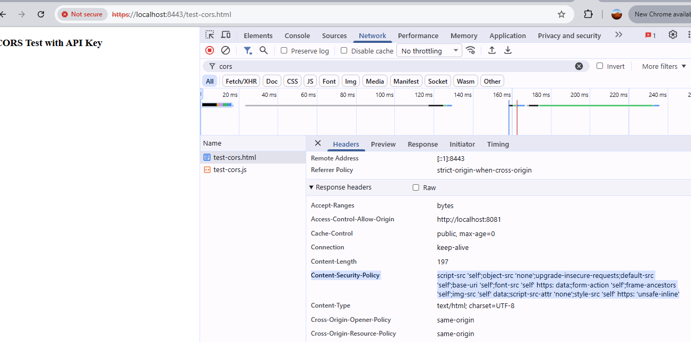

Step 4: Logging & Monitoring (SOC Perspective)
Goal: Track and analyze security events to support SOC monitoring
Implementation:
logger.warn("Failed login attempt");
logger.warn("Invalid API key usage");
logger.warn("Rate limit violation");
What to Log:
- Failed login attempts
- Invalid API key usage
- Rate limit violations
Screenshot:
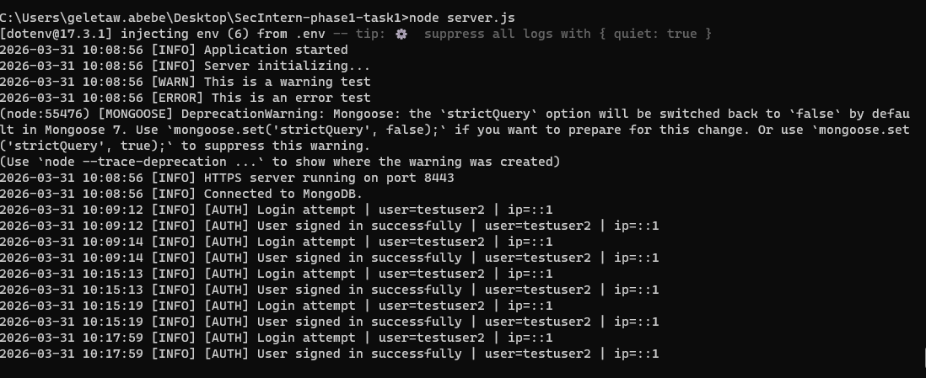
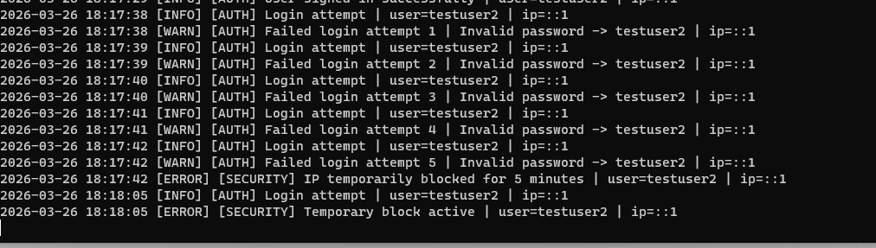

Step 5: Testing Scenarios
Test Cases:
- Normal Access – Access public routes successfully
- Login Success – Receive JWT token
- API Key Failure – Expect 401 Unauthorized
- Rate Limit Attack – Multiple requests → 429 Too Many Requests
- Brute Force Simulation – Multiple failed login attempts → alert/log generated

Final Deliverables
- Intrusion Detection (Fail2Ban/log monitoring)
- Rate Limiting implemented
- CORS restriction applied
- API Key Authentication enabled
- JWT Authentication enabled
- Helmet + CSP headers configured
- HTTPS + HSTS enforced
- Logging & Monitoring implemented
- Test cases verified

Conclusion
This implementation successfully demonstrates a layered security approach combining detection, prevention, and protection mechanisms. The system is now resilient against common threats such as:
- Brute-force attacks
- Unauthorized API access
- Cross-site scripting (XSS)
- API abuse and DoS
The controls implemented align with OWASP Top 10 standards and reflect real-world SOC and Security Engineering practices.

